1. **Introduction**

The introduction of the project (QArena) provides an overview of the entire SRS with purpose, scope.

* 1. **Purpose**

The aim of the project is to build academic community among researchers, faculty, and student so that they can enhance their knowledge and share resource will also helpful for the user on their research topic.

* 1. **Scope**

This project is a web application. It will use in every academic related purpose. It focuses on the academic, research, the stakeholders (students, faculty and others) and applications which allow for online knowledge sharing .

1. **Overall Description**

Students can ask question when they want. But for that they have to register first if they don’t have account. The others members who will available in online at that moment they will help by giving answers of the questions. One new page will create for giving answers against each question. They can see others questions and answers as well as their own questions and answers. They can also select ‘like’ option for any particular question answer. One new page will create for giving answers against each question.

1. **System Analysis**

For this project requirements are -

* 1. **Functional requirement**

This subsection contains the requirements for the QArena. These requirements are organized by the features discussed in the vision document. Features from vision documents are then refined into use case diagrams and to sequence diagram to best capture the functional requirements of the system.

* + 1. **Join us**

This option is for new users whose haven’t account. If they select this option they will get a page for sign up in which they have to fill up username, mail address, password. After that they will be a member.

* + 1. **login**

This section is for members whose have account. They can login easily through username and password.

* + 1. **Ask questions**

In this section user can ask a question on a particular problem and can query for any academic topic which they want to know.

* + 1. **Give answer**

User can give an answer or suggestions on a particular question asked by other user. Also can helped by uploading online resource.

* + 1. **Like**

User can select ‘like’ option if they like any answers or questions.

* + 1. **Update profile**

They can update profile if they want.

* + 1. **Delete question**

User can delete his own question but can not others question.

* 1. **Non-functional requirements**
* Email id must be valid
* Username must be unique
* Password must be valid
* To update profile one have to give all information

1. **System Design**

This section is important section because base on design project can be improved. Design can represent the overview of the project.

* 1. **Use-Case diagram**



* 1. **Sequence diagram**
     1. **Sequence diagram for answer page**



* + 1. **Sequence diagram for ask question page**
  1. **Activity diagram**

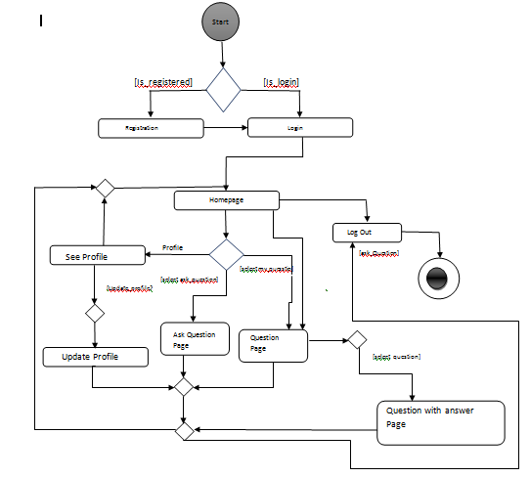

1. **Sample output** 
   1. **Screen shoot for login page**

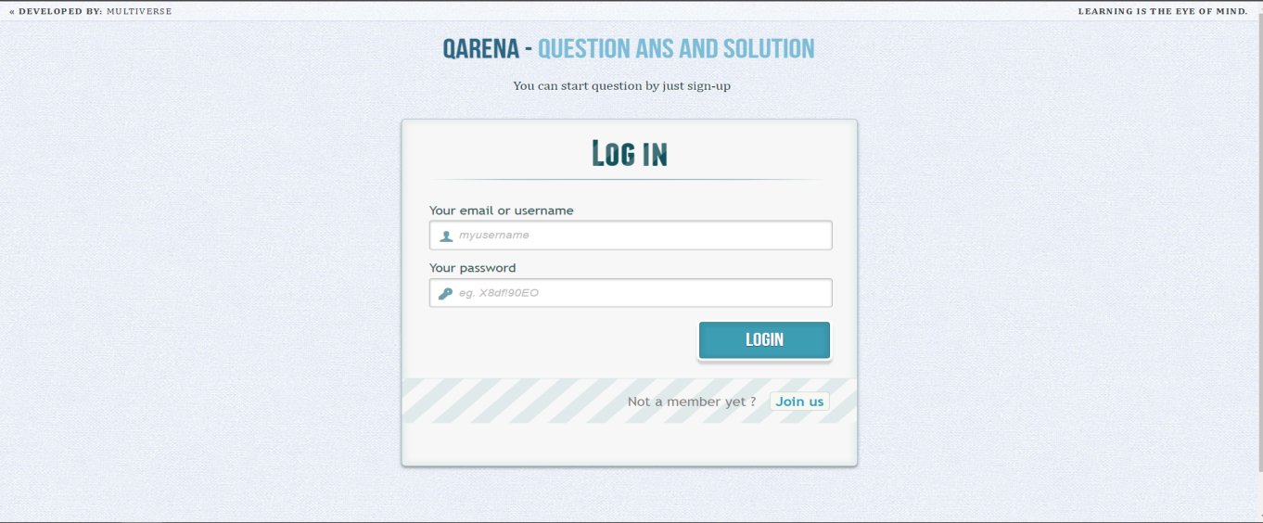

* 1. **Screen shoot for homepage**

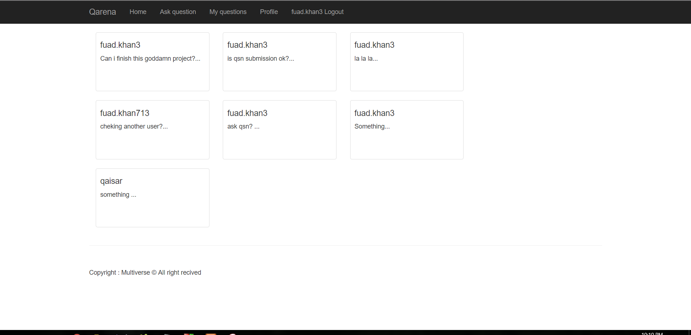

**5.3 Screen shoot for ask question page**

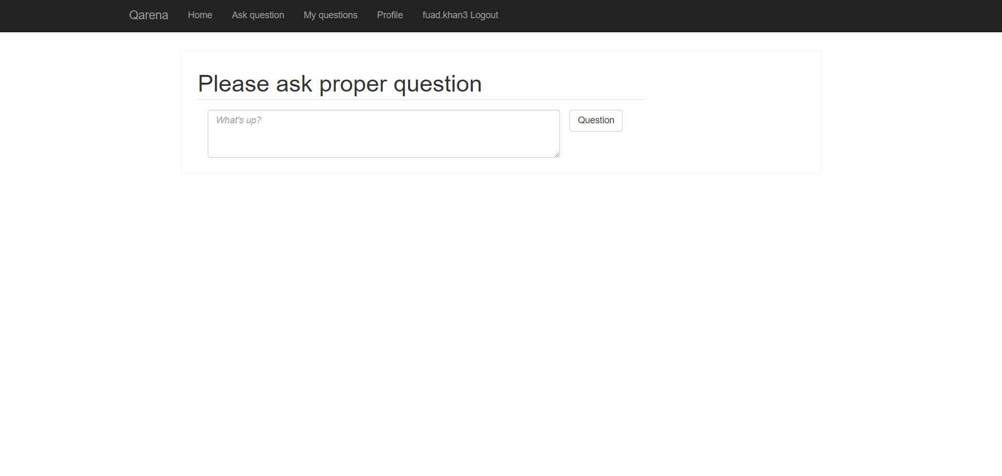

* 1. **Screen shoot for edit profile page**

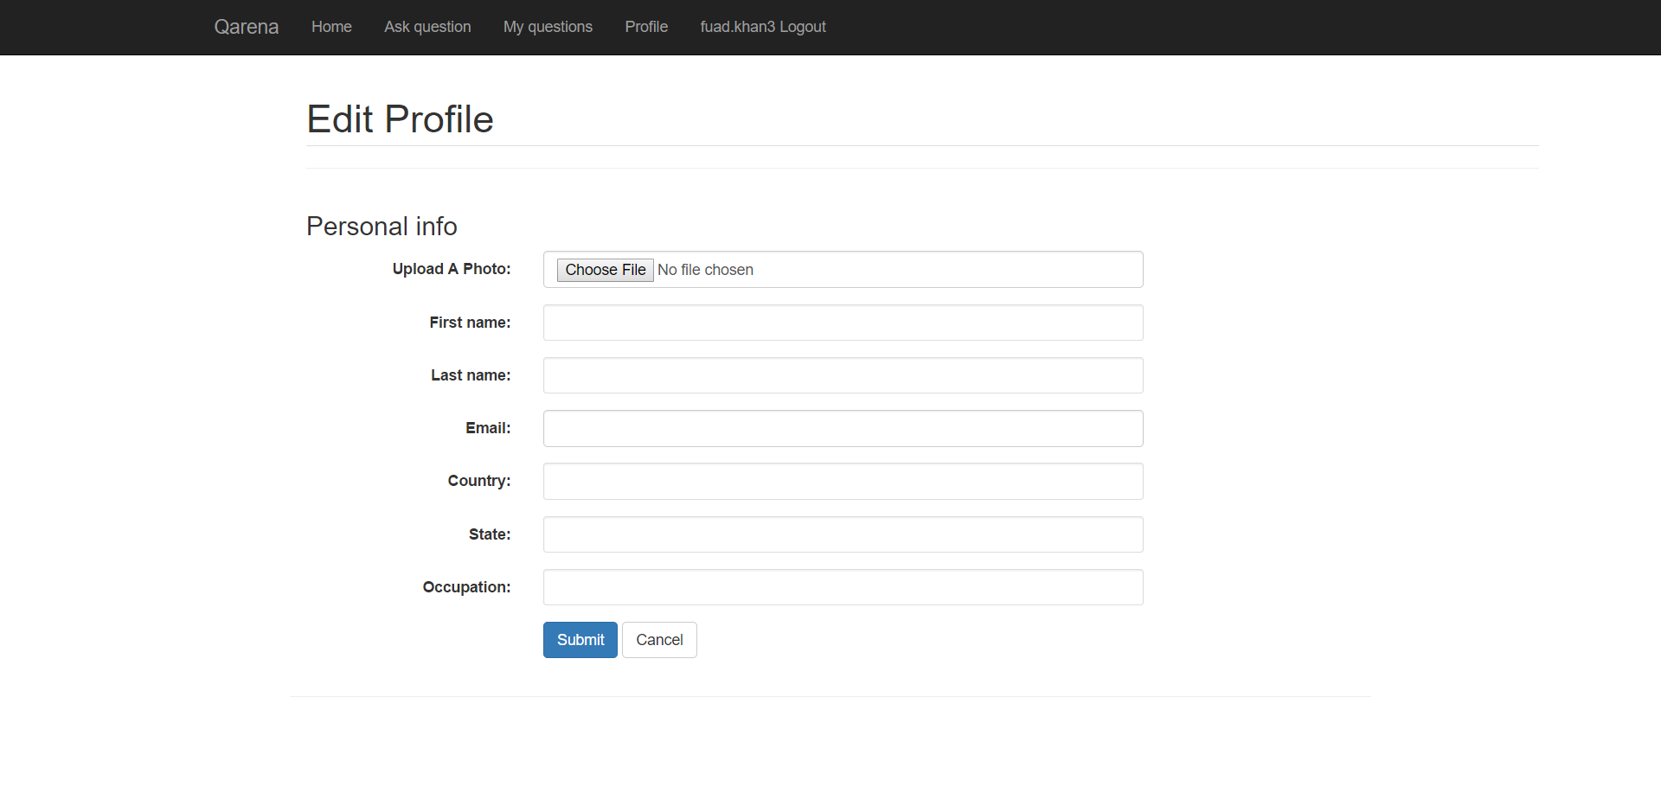

* 1. **Screen shoot for sign up page**

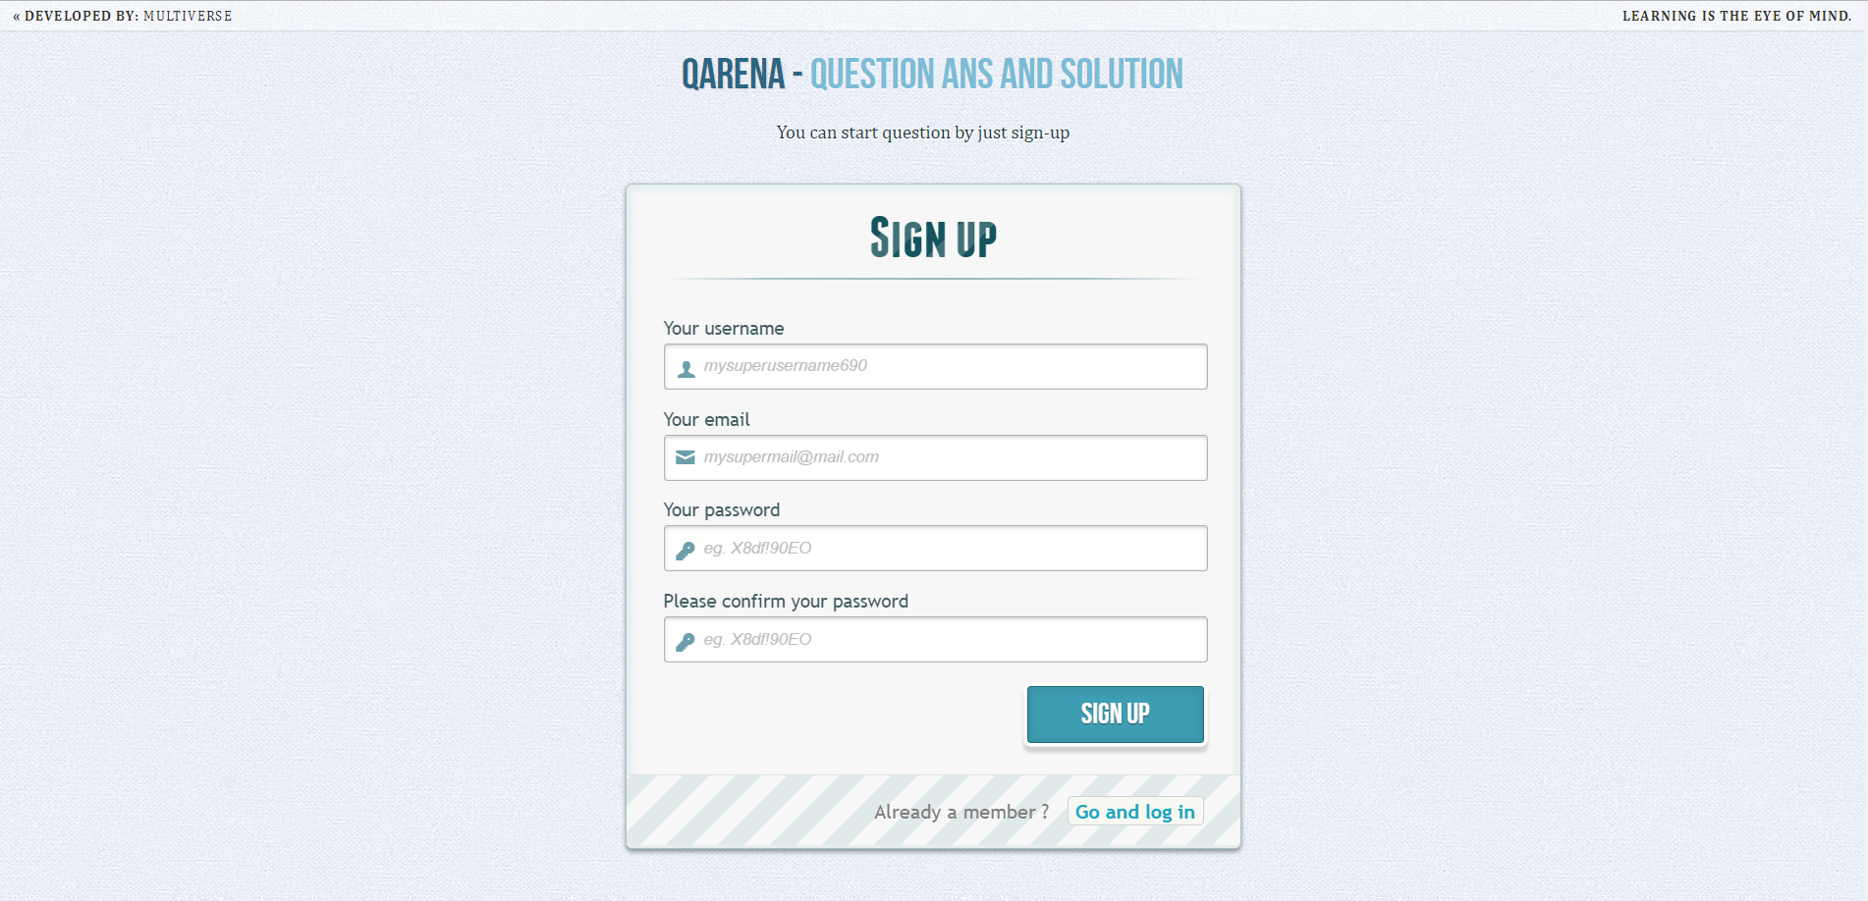

* 1. **Screen shoot for question with answer page**

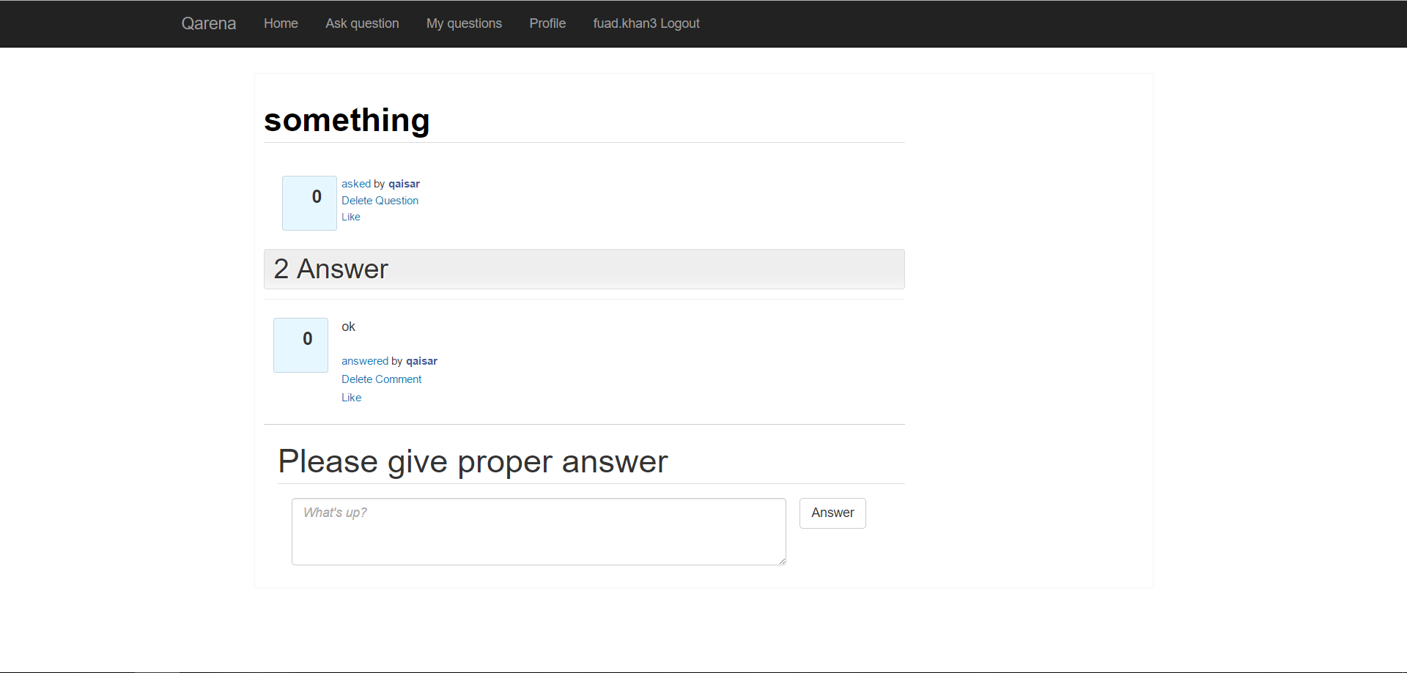

* 1. **Screen shoot for like question page**

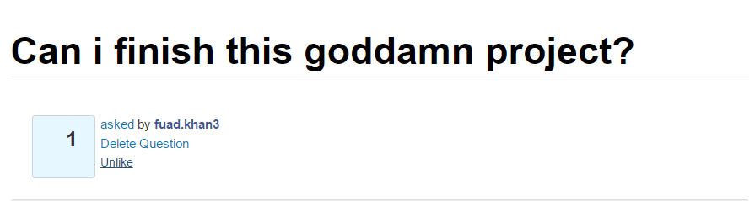

1. **Future work**

This project can be developed by adding some features like sharing pdf file of books, write comments against an answer, software will give rates to the answers etc.